Techno - Commercial Offer -

Technical Specification for Product

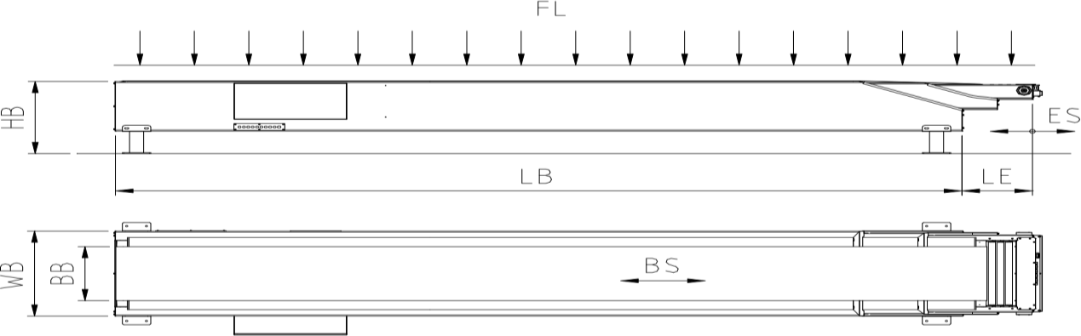

Sr. No. | PARTICULARS | Specifications
1 | Base Section Length (LB) | 6500mm
2 | Telescopic Length (LE) | 4000+4000+4000 mm
3 | Total Extended Length (LB+LE) | 6500+12000=18500mm
4 | Working Height (HB) | 800 mm
5 | Belt Width (BB) | 650 mm
6 | Belt Type | 2 Ply 3.2 mm PVC
7 | Belt Speed | 15-30 mtr/min
8 | Belt Direction | Loading/Unloading
9 | Belt Load Max. (FL) | 50 kg/mtr
10 | Belt Drive | 3 HP [ With Bonfiglioli Gearbox]
11 | Telescoping Speed | 8-10 Mtr/min
12 | Telescopic Drive | 2HP [ With Bonfiglioli Gearbox]
13 | Main Voltage | 415Volt 50Hz 3-Phase

14 | Control Voltage | 24 Volt DC
16 | ELECTRIC MOTOR | Bonfiglioli /BBL/siemens , IE2
17 | Height adjustable with hydraulic arrangement | Yes Tank capacity 12 ltr
18 | Movable (Wheel Arrangement) | Yes
19 | Safety Sensors | Yes
20 | Inclination Considered | 1200mm-1400mm
21 | 6 digit Counter system (Andon Display) | Yes

- Electricals
Sr.  No. | COMPONENTS | MAKE
1 | Electric Motor | Bonfiglioli
2 | Contactor/Over Load Relays/VFD | Siemens/L&T /Schneider/Mitshubishi
3 | MCB/MPCB/Indicators | Siemens/L&T /Schneider
4 | Panel Box Enclosure | DL TECH
5 | Push Buttons/Limit Switches | Teknik/ Siemens/Schneider
6 | Fittings | Standard
7 | Cables | Polycab/RR
8 | Connectors | Phoenix/Connectwell/Elemek

- Hydraulics
Sr.  No. | COMPONENTS | MAKE
1 | Power Pack | Target innovation
2 | Hydraulic Cylinders | DL TECH
3 | Hydraulic hose pipe | Parker
4 | Hydraulic Oil | Servo VG 68

- Others
Sr.  No. | COMPONENTS | MAKE
1 | Gear Box | Bonfiglioli
2 | Belt | PVC (Forbo)
3 | Bearing & Bearing Units | SKF
4 | Return Roller | DL TECH Make
5 | Drive & Driven Roller | DL TECH Make
6 | Chain & Sprockets | TI Diamond
7 | MOC | Mild Steel Jindal/Apollo
8 | Surface Treatment | Powder Coated

Commercial Offer -

Sr. | Description | Qty  (Unit ) | Price in INR/  Unit | Price in INR/ Unit
1 | Basic cost of Telescopic conveyor – (6.5mtr,4+4+4 mtr width 650mm) | 1 | 1450000 | 1450000  + GST

